**Timing.**

**Comparison of arrival time of a specific seismic wave train as recorded by five instruments.**

**Using PSN and EchoPro equipment.**

**PSN** [Larry Cochrane equipment] and the **EchoPro** [ES&S equipment].

**PSN.**

a) VolksMeter A horizontal displacement. located at TPSO. Uses internal Larry PCB.

b) VolksMeter B horizontal displacement. located at TPSO. Uses internal Larry PCB.

c) Wilmore 1 Second Vertical located at TPSO. Uses 24 bit Larry PCB

d) Sprengnether 20 Second Vertical located at TPSO. Uses 24 bit Larry PCB.

NOTE: The 24 bit Larry PCB is a 4 channel board, receiving both the Wilmore and the Sprengnether signal.

**EchoPro.**

e) Guralp CMG-6T-1 3 axis 1 Second to 100 Hz located at HMV1. Uses EchoPro digitizer.

NOTE: TPSO is located at 35.489 S 138.637 S. HMV1 is located 102 metres to the South of TPSO, so any difference in arrival time of a particular seismic wave train at these two stations, is of the order of no more than 0.02 seconds.

**Seismic Wave Train**

The seismic wave train used for timing, is the **peak** of the first big S wave arriving from the Strathalbyn quake of 2016-03-29       22:07.

**Horizontal**

**VolksMeter A.**

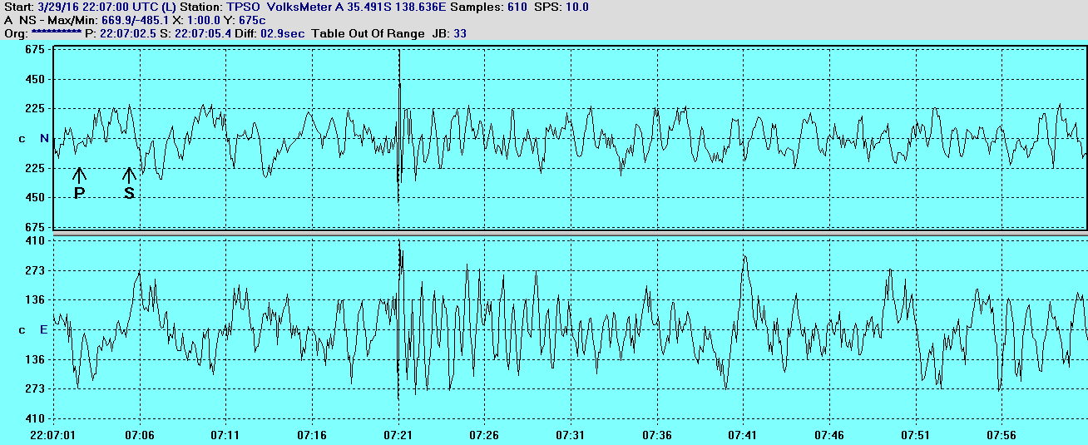

The peak of the first big S wave arrival time from VolksMeter A is  **22:07:21.0**  for both N/S and for E/W.    Remember VolksMeter only records at 10 SPS.

**VolksMeter B**

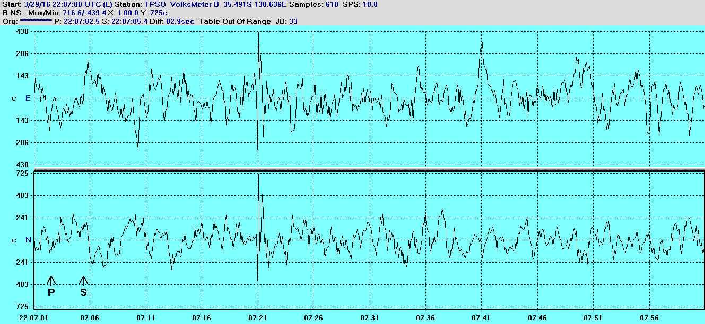

The peak of the first big S wave arrival time from VolksMeter B. Timing for both N/S and for E/W  is **22:07:21.0.**

**Guralp**

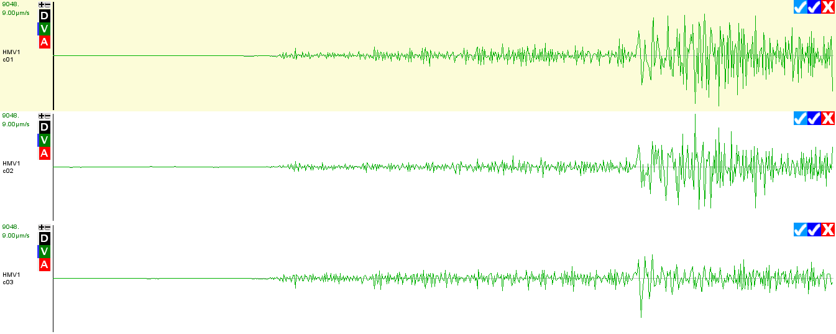

The peak of the first big S arrival time from the Guralp E/W is at   **22:07:21.034**, and for the N/S   **22:07:21.034.**

 The peak of the first big S arrival time from the Guralp VERTICAL is **22:07:21.034.**

 That is all three axis from the Guralp show **22:07:21.034.**

Vertical traces from Wilmore and Sprengnether shown on next page.

**Vertical**

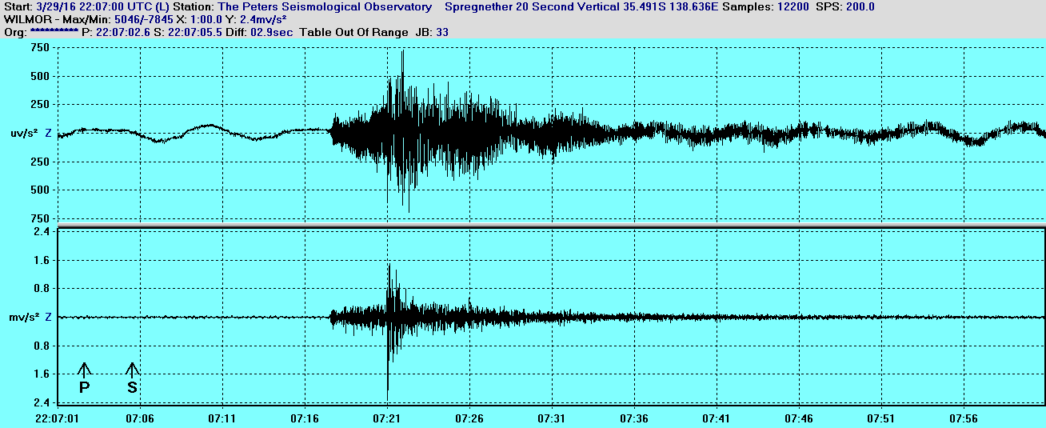

The top trace is the Sprengnether 20 Second Vertical which shows the peak of the first big S wave at **22:07:21.038**

The lower trace is the Wilmore 1 Second vertical which shows the peak of the first big S wave at  **22:07:21.042.** Note both Wilmore and Sprengnether are both timed from the same 24 bit LARRY Board.

From the Guralp 3 axis trace previously, it shows a VERTICAL arrival at **22:07:21.034**

Observed arrival time of the peak of the first big S wave.

a) VolksMeter A both N/S and E/W **22:07:21.0** 10 SPS

b) VolksMeter B Both N/S and E/W **22:07:21.0**  10 SPS

c) Wilmore Vertical **22:07:21.042.** 200 SPS

d) Sprengnether Vertical **22:07:21.038** 200 SPS

e) Guralp all three axis   **22:07:21.034.** 100 SPS

As can be seen there is good correlation in the timing between all 5 instruments.

And between all 9 traces.

Good correlation between the PSN equipment and the ES&S equipment.